ONEWAY CS BY Age
/STATISTICS DESCRIPTIVES HOMOGENEITY WELCH
/PLOT MEANS
/MISSING ANALYSIS.

Oneway

Notes
Output Created |  | 05-May-2019 23:17:44
Comments
Input | Active Dataset | DataSet0
Input | Filter | <none>
Input | Weight | <none>
Input | Split File | <none>
Input | N of Rows in Working Data File | 30
Missing Value Handling | Definition of Missing | User-defined missing values are treated as missing.
Missing Value Handling | Cases Used | Statistics for each analysis are based on cases with no missing data for any variable in the analysis.
Syntax |  | ONEWAY CS BY Age  /STATISTICS DESCRIPTIVES HOMOGENEITY WELCH  /PLOT MEANS  /MISSING ANALYSIS.
Resources | Processor Time | 00 00:00:00.203
Resources | Elapsed Time | 00 00:00:00.191

[DataSet0]

Descriptives
 | N | Mean | Std. Deviation | Std. Error | 95% Confidence Interval for Mean
 |  |  |  |  | Lower Bound | Upper Bound
18 | 1 | 40.0000 | . | . | . | .
19 | 2 | 40.0000 | .00000 | .00000 | 40.0000 | 40.0000
20 | 2 | 40.0000 | .00000 | .00000 | 40.0000 | 40.0000
21 | 2 | 38.0000 | 2.82843 | 2.00000 | 12.5876 | 63.4124
22 | 9 | 38.1111 | 2.84800 | .94933 | 35.9219 | 40.3003
23 | 1 | 40.0000 | . | . | . | .
24 | 1 | 40.0000 | . | . | . | .
25 | 1 | 40.0000 | . | . | . | .
28 | 2 | 36.5000 | 4.94975 | 3.50000 | -7.9717 | 80.9717
30 | 1 | 40.0000 | . | . | . | .
41 | 1 | 40.0000 | . | . | . | .
43 | 1 | 40.0000 | . | . | . | .
48 | 3 | 40.0000 | .00000 | .00000 | 40.0000 | 40.0000
52 | 1 | 36.0000 | . | . | . | .
56 | 1 | 28.0000 | . | . | . | .
58 | 1 | 36.0000 | . | . | . | .
Total | 30 | 38.4000 | 3.00115 | .54793 | 37.2794 | 39.5206

Descriptives
 | Minimum | Maximum
18 | 40.00 | 40.00
19 | 40.00 | 40.00
20 | 40.00 | 40.00
21 | 36.00 | 40.00
22 | 34.00 | 40.00
23 | 40.00 | 40.00
24 | 40.00 | 40.00
25 | 40.00 | 40.00
28 | 33.00 | 40.00
30 | 40.00 | 40.00
41 | 40.00 | 40.00
43 | 40.00 | 40.00
48 | 40.00 | 40.00
52 | 36.00 | 36.00
56 | 28.00 | 28.00
58 | 36.00 | 36.00
Total | 28.00 | 40.00

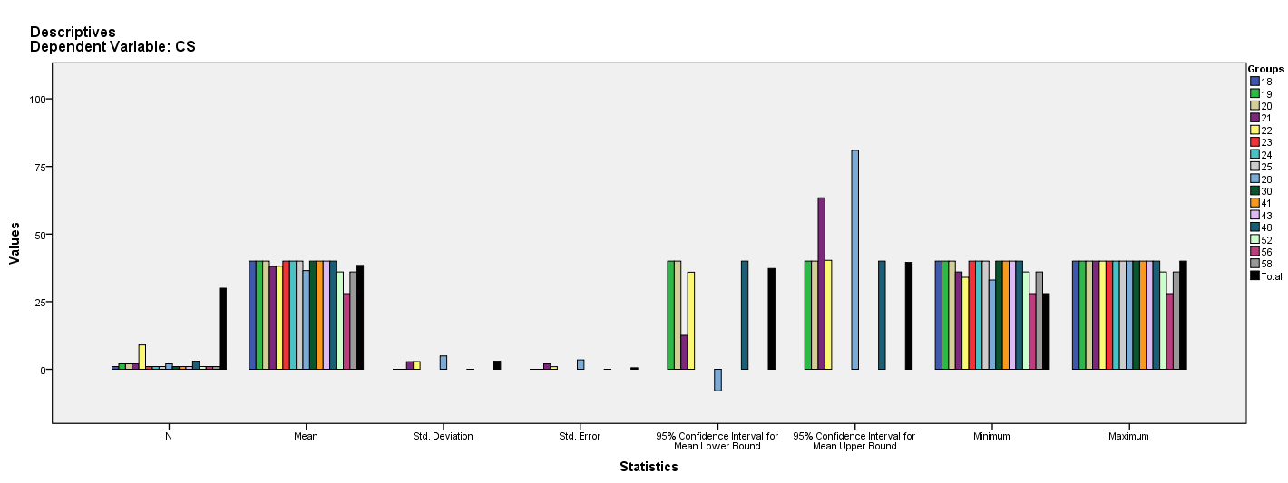

Test of Homogeneity of Variances
CS
Levene Statistic | df1 | df2 | Sig.
11.812ª | 5 | 14 | .000
a. Groups with only one case are ignored in computing the test of homogeneity of variance for CS.

ANOVA
CS
 | Sum of Squares | df | Mean Square | F | Sig.
Between Groups | 163.811 | 15 | 10.921 | 1.570 | .203
Within Groups | 97.389 | 14 | 6.956
Total | 261.200 | 29

Robust Tests of Equality of Means^{b}
CS
 | Statisticª | df1 | df2 | Sig.
Welch | . | . | . | .
a. Asymptotically F distributed.
b. Robust tests of equality of means cannot be performed for CS because at least one group has the sum of case weights less than or equal to 1.

Means Plots

